The Story
Session 17: "The Beginning of the End (of the Kingdom of Israel)"
Buhler Mennonite Church Sanctuary (and BMC YouTube live-stream) – April 21, 2021
____________________________________________________________________________________________

"Come, all you who are thirsty, come to the waters; and you who have no money, come, buy and eat!"
_{ISAIAH 55:1 (NIV)}

- Opening & Praying
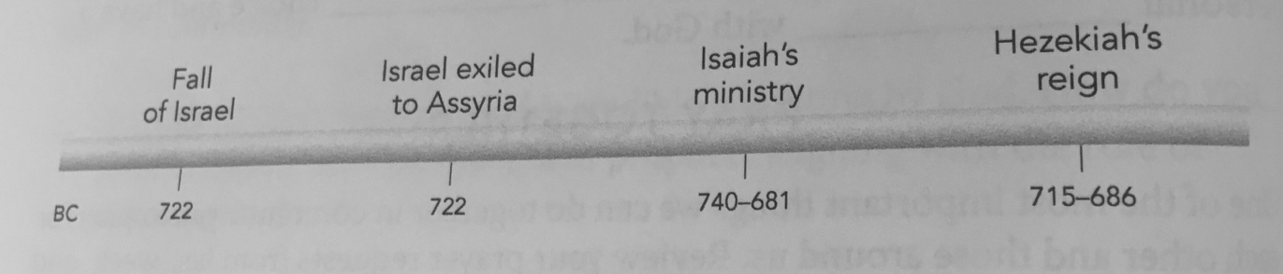
- Review: As we go through The Story together, we want to learn how to tell the story. Commit Movement 2 & 3 to memory.

MOVEMENT 1: "In the UPPER STORY, God creates the LOWER STORY. God's vision is to come down and be with us in a beautiful garden. The first two people reject God's vision and are escorted from paradise. Their decision introduces sin into the human race and keeps us from community with God. At this moment God gives a promise and launches a plan to get us back. The rest of the Bible is God's story of how God kept that promise and made it possible for us to enter a loving relationship with God.

MOVEMENT 2: "God builds a brand-new nation called Israel. Through this nation, God will reveal his presence, power, and plan to get us back. Every story of Israel will point to the first coming of Jesus
--the One who will provide the way back to God."

MOVEMENT 3: "Jesus left the UPPER STORY to come down into our LOWER STORY to be with us and to provide the way for us to be made right with God. Through faith in Christ's work on the cross, we can now overturn Adam's choice and have a personal relationship with God."

- Introduction: WATCH THE SCRIPTURE VIDEO

"Even when things seem hopeless, prayer still makes a difference. Give it a try."

- Reflect on it/Talk About It: Tell about a time you watched a sporting event that looked like it was over, but a team that seemed defeated made an amazing comeback.

- Know the Story: Pop Quiz

- How did Hezekiah respond when the Assyrians threatened to attack him?
- He assembled all the fighting men of Israel over the age of twenty.
- He went up to the temple of the Lord to pray.
- He sent word to the king of Cush to come to their aid.
- He made a peace treaty with King Sennacherib to spare his people.

- What was Isaiah's response when he had a vision of the LORD seated on the throne?
  - "Great is the LORD and worthy to be praised!"
  - He said nothing, and he got on his face in worship before the LORD.
  - "Woe is me! For I am a man of unclean lips!"
  - He tore his clothes and put on sackcloth and ashes.

- What were the prophetic words Isaiah spoke to Israel?
  - The LORD will have compassion on you and settle you in your own land.
  - Destruction is around the corner, and you will be sent into exile in Egypt.
  - These are days of freedom and prosperity, but trouble is on the horizon.
  - All of the above.

- What are the words Isaiah speaks about a coming Messiah
- He was led like a lamb to the slaughter.
- He had no beauty or majesty to attract us to him.
- The LORD has laid on him the iniquity of us all.
- All of the above.

- Understand the Story: Video with Randy Frazee
Video Guide: As you watch the video use the following outline to record anything that stands out to you.

- "No King but King Jesus":

- The beginning of the end for Israel, the Northern Kingdom:

- God's prophets spoke to the northern kingdom for ____________ years.

- King Hezekiah: one of the Southern Kingdom's good kings:

- Hezekiah did what was ___________ in the eyes of the LORD.

- Isaiah's proclamation of God's purpose:

- Isaiah told Hezekiah that God has got your ________________ .

- "Then you will know that I am the ________________ . "

- No _____________ but King Jesus.

- Video Discussion/Journaling: Write down your answers.

- What part of Randy's teaching encouraged or challenged you the most? Why?
Did anything jump out, calling you to action? Did anyone have an "aha!" moment?

  - Today's lesson covers more than 200 years. The Northern Kingdom of Israel fell to the Assyrians in 722 BC and was never heard from again. The Southern Kingdom of Judah fell to the Babylonians in 586 BC but had an amazing comeback 70 years later when they returned from captivity. How do you see God's patience and commitment to bring his people back to himself woven through these two centuries of history?

We see over and over again in the Bible, that when we put God on the throne of our lives, we put ourselves in the best possible position for success.

  - Hezekiah of Judah was one of the few kings deemed, "good" in the eyes of God (2 Kings 18-19; THE STORY pp. 220 - 224). What did Hezekiah do that pleased God and how can we learn from his example?

How can Hezekiah's prayer shape the way you pray when times are tough?

- Through the prophets Amos and Hosea, God pointed out the people's sin and actions of rebellion (THE STORY, pp. 213-217). What were some of Israel's sins and why do you think God was being so severe with them?

- The Bible has a lot to say about pride. What do you learn about pride in the encounter between Assyria and Israel in today's lesson?

What is one way we can avoid pride and grow in humility?

- Though the Southern Kingdom of Judah discovered they would one day end up prisoners of war under the fist of a foreign nation, God spoke words of hope through the prophet Isaiah (Is. 14:1-5; Is. 49; THE STORY pp. 226-228). What did God promise and how do you see God continuing to accomplish his plan to bring his people back to himself?

- The final and greatest hope for all of God's people, including you and me, is the promise of the Messiah who would come to deliver us (Isaiah 53; THE STORY, pp. 228-230). What do you learn about Jesus, the promised Savior, from this prophesy?

- How has Jesus been the One who brings your life hope and meaning?

7. Personal Reflection:

Over and over the people of Israel let idolatry creep into their lives, homes, culture--even worship. They seemed blind to what they were doing. This week reflect on your lifestyle, choices, hobbies, loves. Is anything becoming an idol, dominating your passion and time to the point that you're not growing in your relationship with Jesus? If so, read 2 Kings 23:1-30, the account of another good king of Judah who did some serious housecleaning to rid idolatry from the land. Compare his passion, zeal, and thoroughness as you consider how you can ensure your life is free of idolatry.

8. Personal Action:

Every morning when you wake up, for the next week, make this simple statement before you get out of bed: "No king but King Jesus!" Then seek to live out this truth each day.

9. Double Check Your Pop Quiz [b/c/a/d]

Video Notes Answer Key: 208 / right / back / LORD / king

10. Next Week: Session 18: "The Kingdoms' Fall" (Lamentations 3:25-26).

