The Story
Session 1: Introduction to God’s Story, Our Story
Buhler Mennonite Church – October 21, 2020
____________________________________________________________________________________________

- Opening & Praying

- Introduction to the Context: In the season of COVID-19 and the joys of technology! Please spread-out and wear a face-covering as much as possible.

- Orientation Video: Randy Frazee

- The Lower Story & the Upper Story:

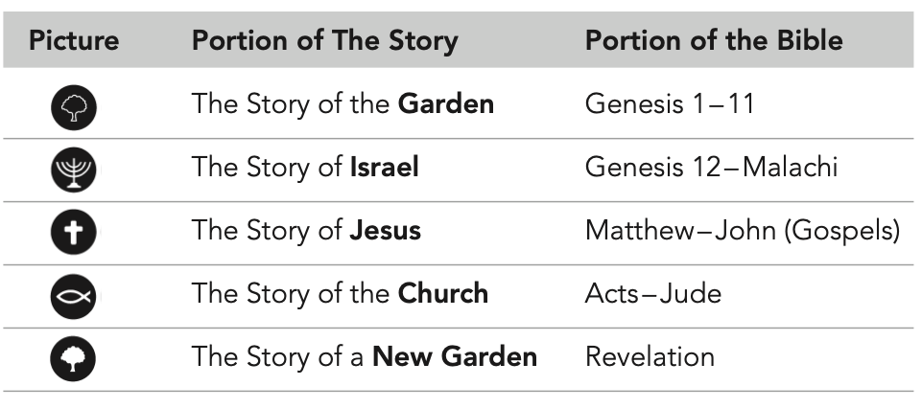

- Proposed Schedule:

- October 28: Session 2: Creation: The Beginning of Life as We Know It (Genesis 1:1)
- November 4: Session 3: God Builds a Nation (Genesis 17:7)
- November 11: Session 4: Joseph: From Slave to Deputy Pharaoh (Genesis 50:20)
- November 18: Session 5: Deliverance (Exodus 13:3)

- Resources (not needed but helpful) The following resources can be ordered on-line. If you need help ordering do not hesitate to contact me:
- The Story: Study Guide. ISBN 978-0-310-08443-3
- The Story: The Bible As One Continuing Story of God and His People. ISBN 978-0-310-95097-4

- The “Read Thru the OT” Challenge: Reading Plan Handout

